**1.Step** Install Python 2.7.x

a. Open the link <https://www.python.org/> and click Python 2.7.10

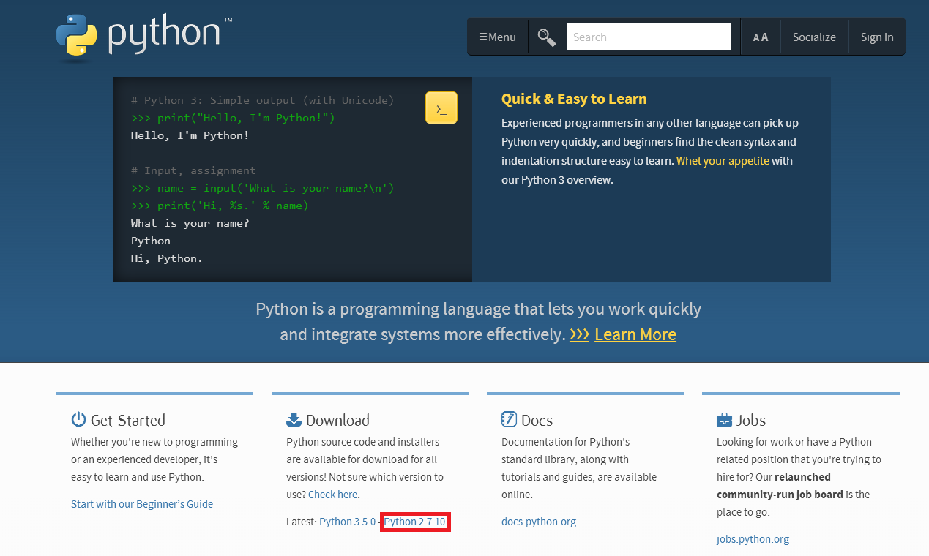

b. donwload the windows Installer(64bit or 32bit) and insall it, the first one “Windows x86-64 MSI installer” is for 64bit.

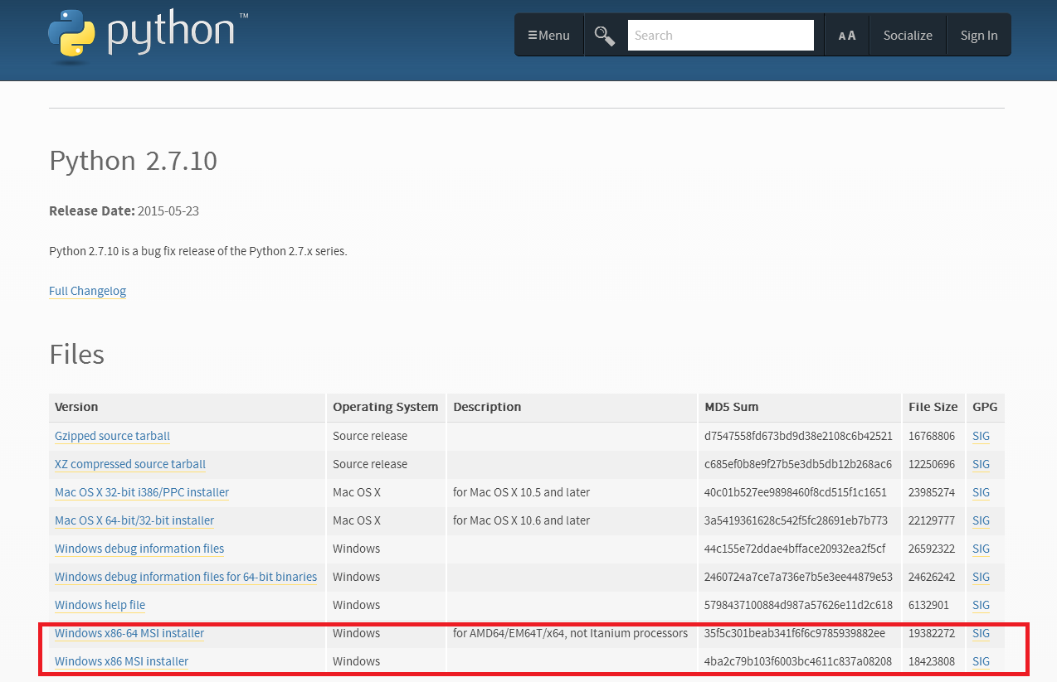

c. after the install, find your Python27 file

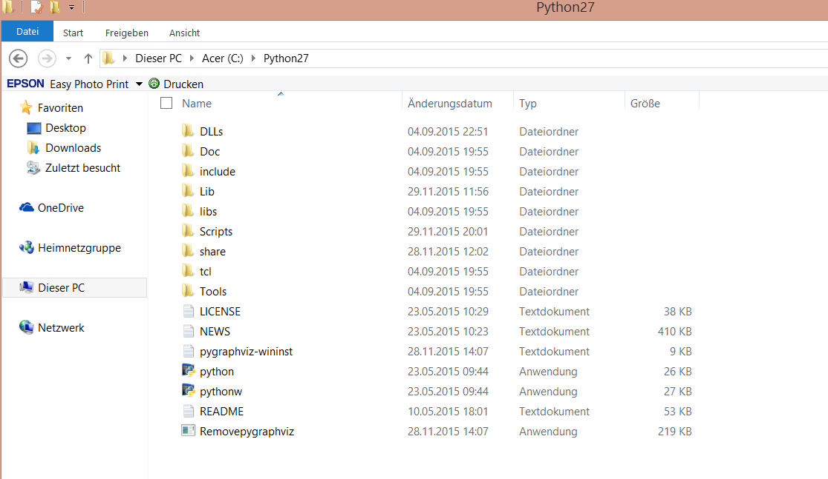

d. open the file “Scripts”, find if pip is included, because Python 2.7.9 and later include pip by default.

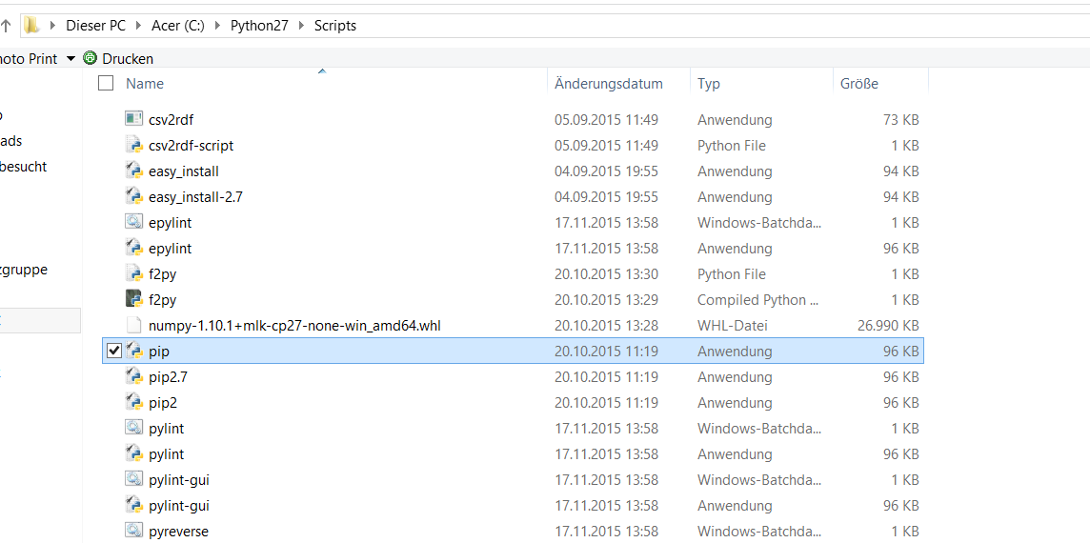

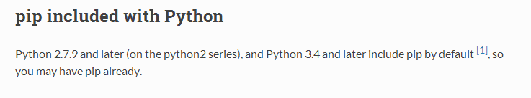

e. open the Environment Variables on windows, add the path of Python on your windows. You can copy the path of Python and Python\Scripts, such as “C:\Python27\” and ” C:\Python27\Scripts” Attention: the path is where Python File in your windows.

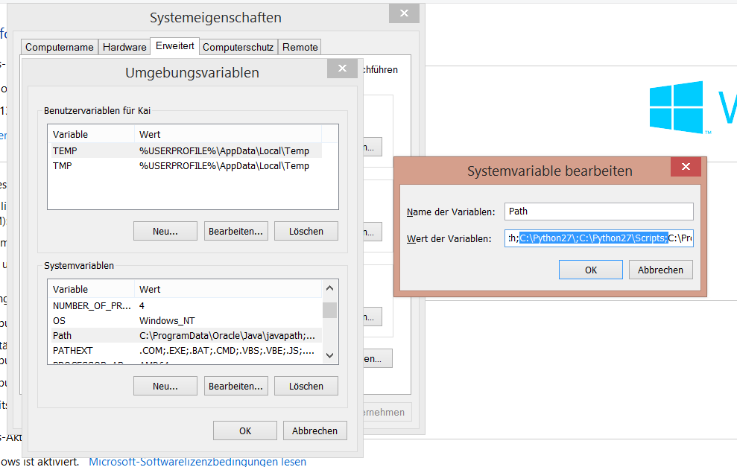

**2.Step** Install Graphviz

a. Open the link <http://www.graphviz.org/> and click Download, and choose windows, choose “graphviz-2.38.msi” or “graphviz-2.38.zip”, download it, install (for .msi) or unzip (for .zip) it.

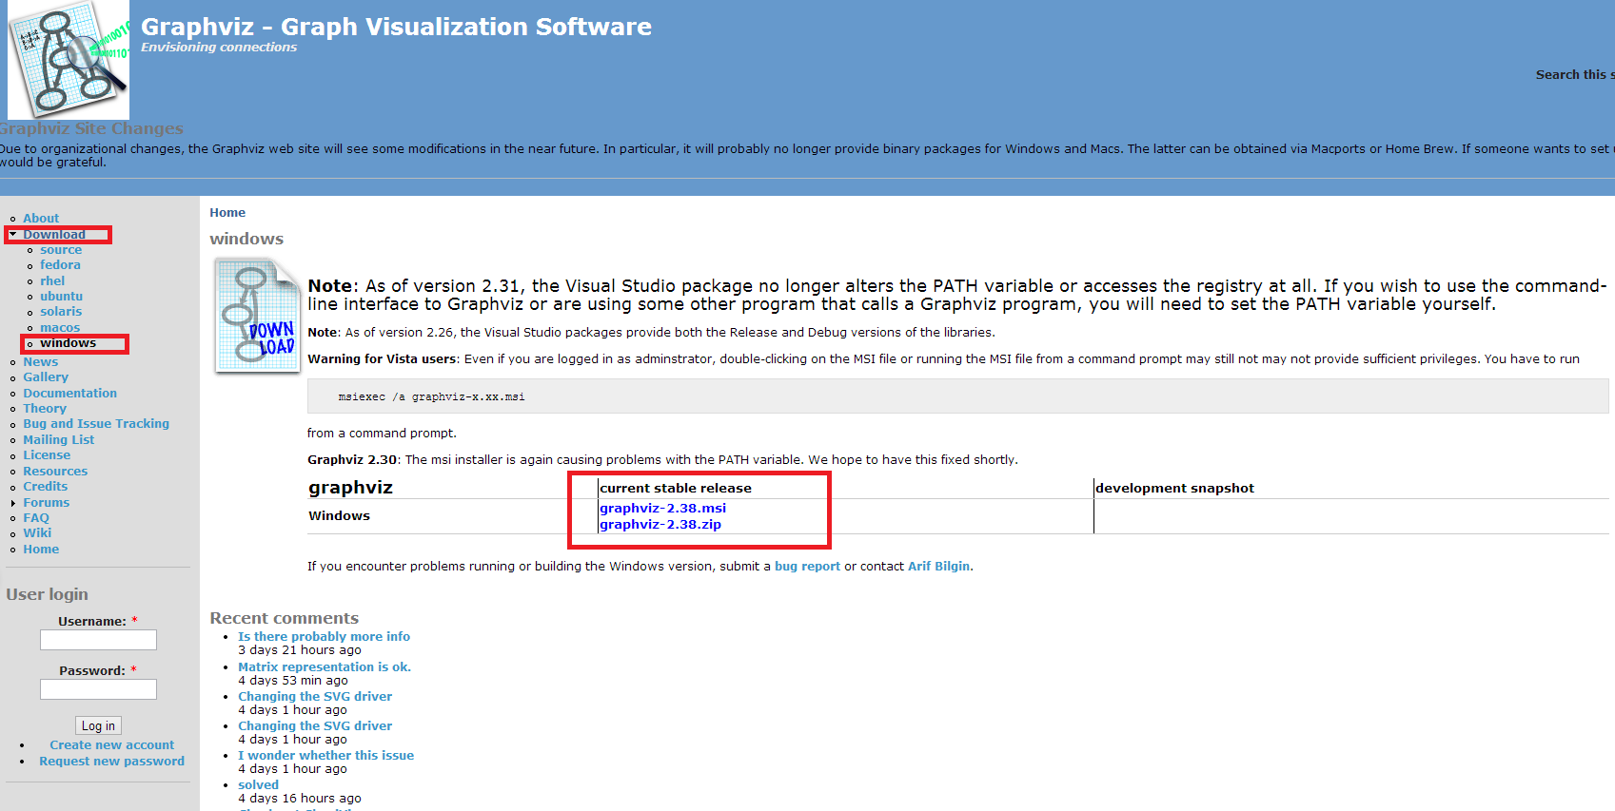

b. after install or unzip, find your Graphviz file, open it, then open file “bin” 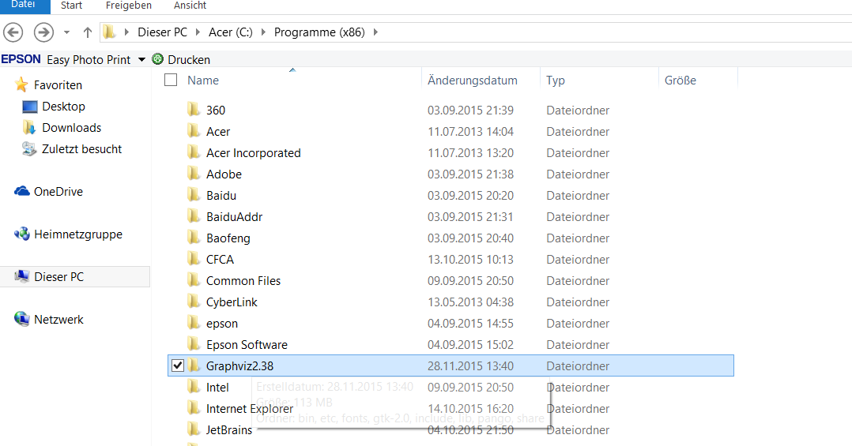

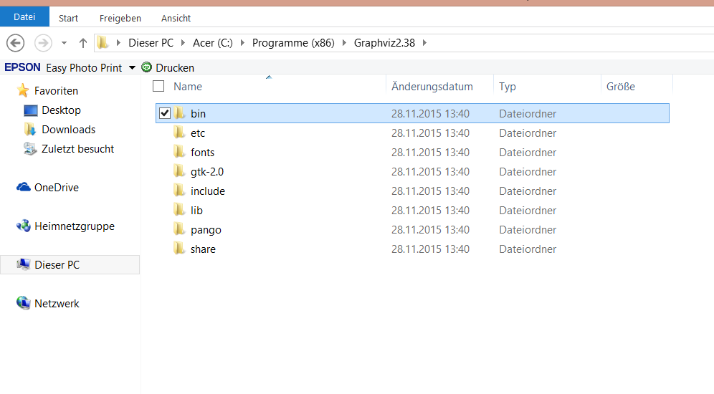

c. copy the path of file bin, such as “C:\Program Files (x86)\Graphviz2.38\bin”, and add it in Environment Variables on windows (see 1.Step e). Attention this step is very important.

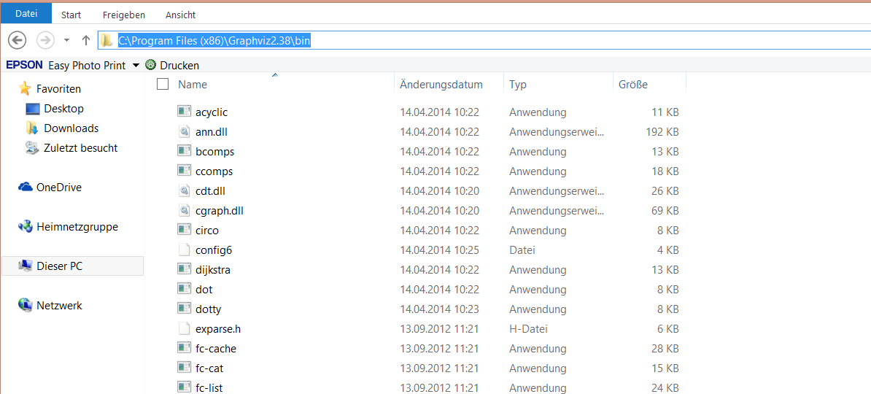

**3.Step** Install pygraphviz

You can do this step in 2 ways.

**The first way. Install Pygraphviz-1.2 with exe**

a. you can get the exe “pygraphviz-1.2.win-amd64-py2.7.exe” in github download and install it, click “next”.

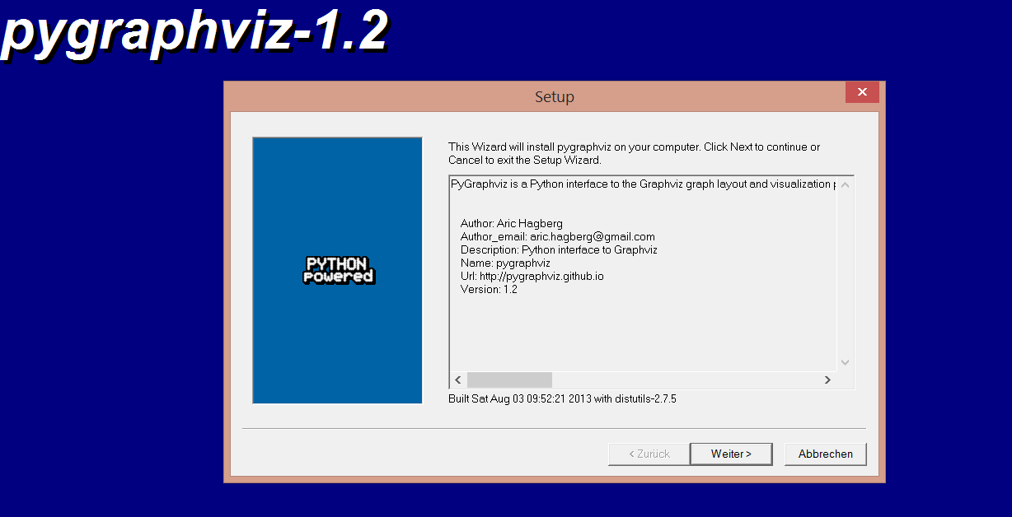

b. Attention, do not change the Paths “Python Directory” and “Installation Directory”, because it finds automatic your Python2.7.x and click “next”.

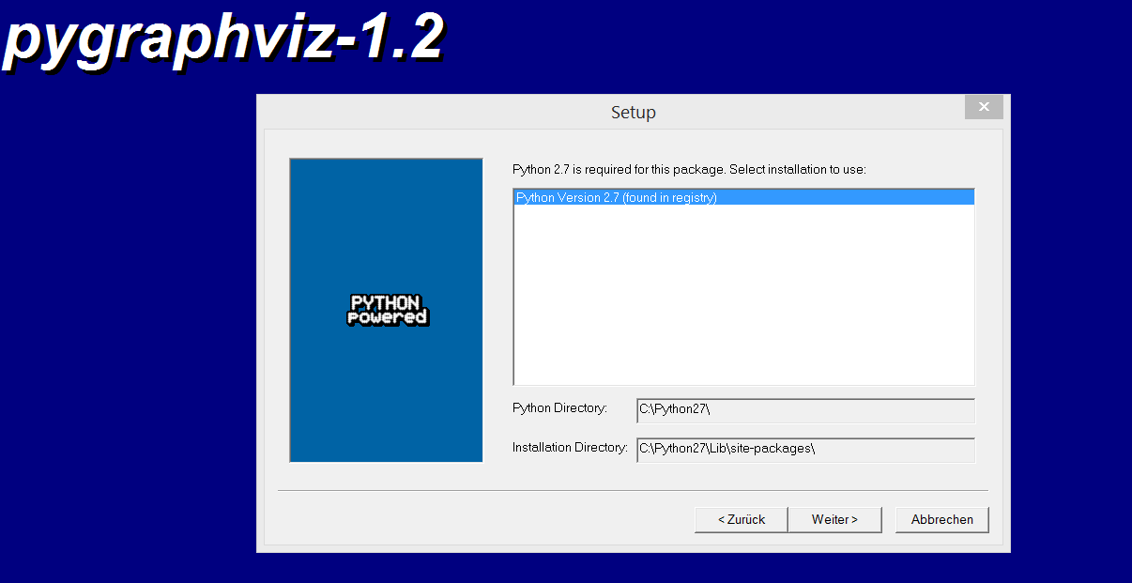

c. after you install it successful, you will see pygraphviz file in your Python.” C:\Python27\Lib\site-packages”

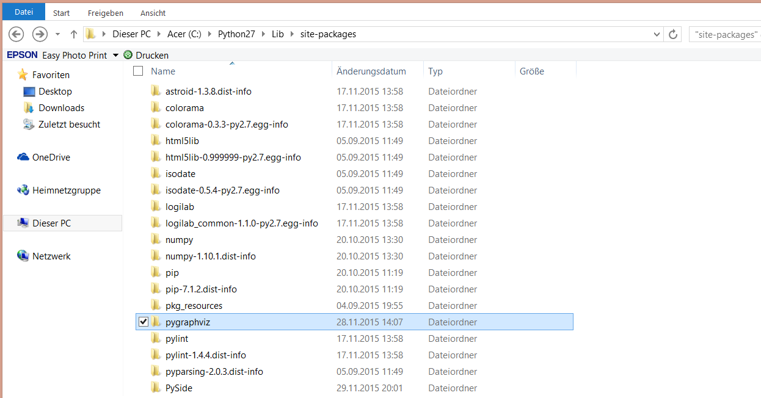

d. if you don’t need pygraphviz any more or you want install another pygraphviz, just delete the file.

” C:\Python27\Lib\site-packages\pygraphviz”

**The second way. Install Pygraphviz-1.3.1 with command lines.**

a. open the link “Unofficial Windows Binaries for Python Extension Packages” <http://www.lfd.uci.edu/~gohlke/pythonlibs> and find pygraphviz, and download “pygraphviz-1.3.1-cp27-none-win_amd64.whl” for 64 bits or “pygraphviz-1.3.1-cp27-none-win32.whl” for 32 bits.

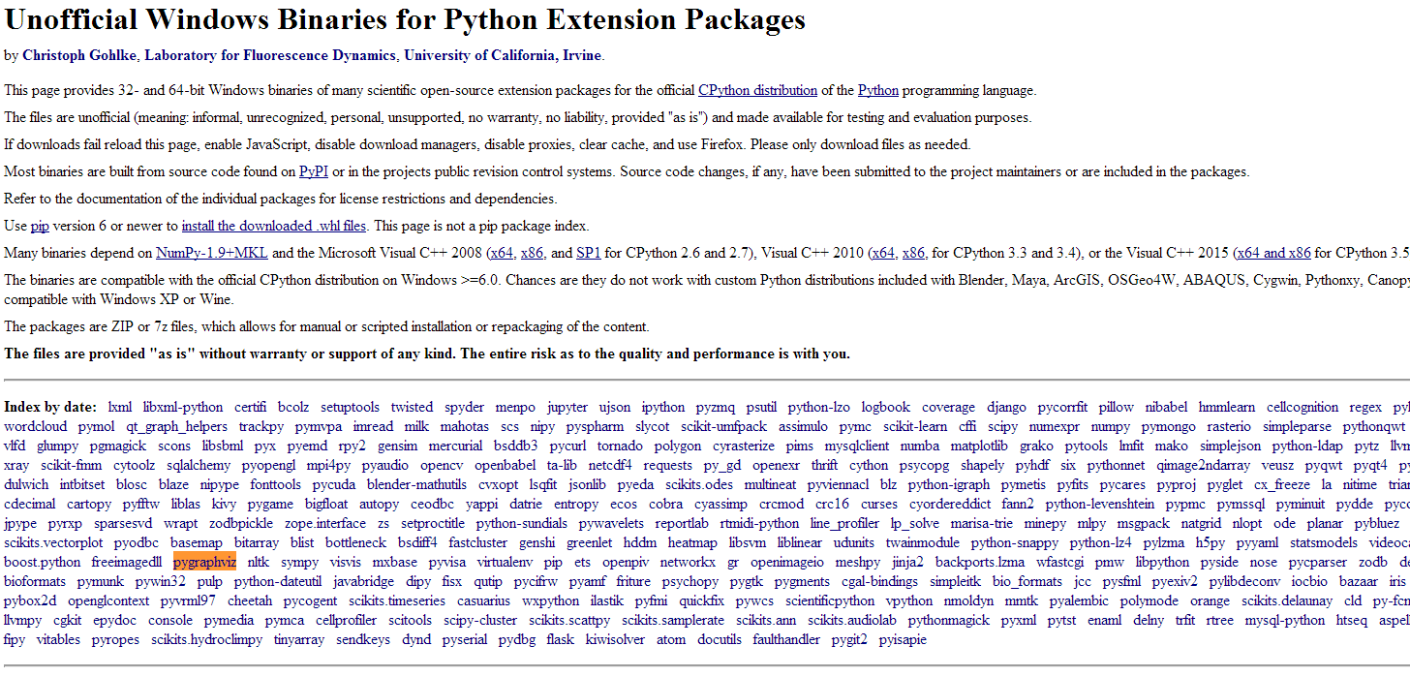

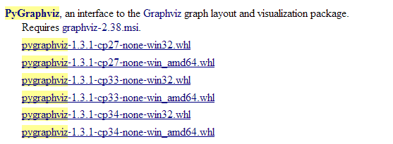

b. open cmd on windows and run this command ”pip install ...”. Attention, make sure you have pip (see 1.Step d)



c. after you install it successful, you will see pygraphviz file in your Python.” C:\Python27\Lib\site-packages”



d. if you don’t need pygraphviz any more or you want install another pygraphviz, just delete the file.

” C:\Python27\Lib\site-packages\pygraphviz”

**3.Step** Install Ot4.8

a. get Ot4.8.6 in link <https://download.qt.io/archive/qt/4.8/4.8.6/>

if it fails, find Ot4.8.6 in http://www.qt.io

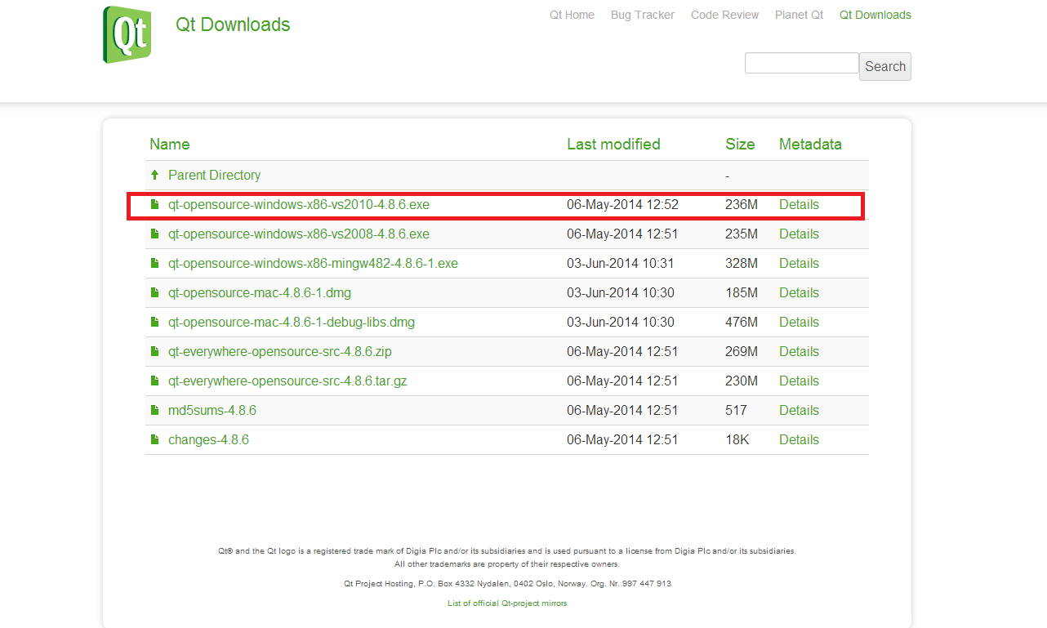

b. install it, and it takes a few minuts.

**4.Step** Install PySide

a. get PySide on link “Unofficial Windows Binaries for Python Extension Packages” <http://www.lfd.uci.edu/~gohlke/pythonlibs/#pyside> (See Step3, the second way)

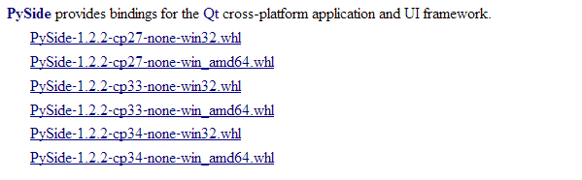

b. run it on cmd



**5.Step** now you can run the EPF Gui, enjoy it.